

School of computer application

First CA

Data Communication and networking (CAP-276)

Submitted to: Submitted by:

Name: Mr Ravinder Singh Name:Rohit Gupta

(Dept of. Computer Science) Course :MCA

Roll No:A31

Department of computer Science

Lovely Professional University Jalandhar Punjab (144401) india.

**1.Design Hybrid network using star and Bus topology Configure it with IP Address.**

Step-1 –First make the Bus topology using switches and the node(Computer/pc).

Step-2-Make the Star topology using switch and the node.

Step-3-Connect Star and the Bus topology by the use of switch and the copper straight wire/copper cross-over cable.

Step-4-Configure the each node (Pc/Computer) by give the Ip address for each node.

Step-5- Check the connectivity using ping command.

Like- ping 192.168.1.2

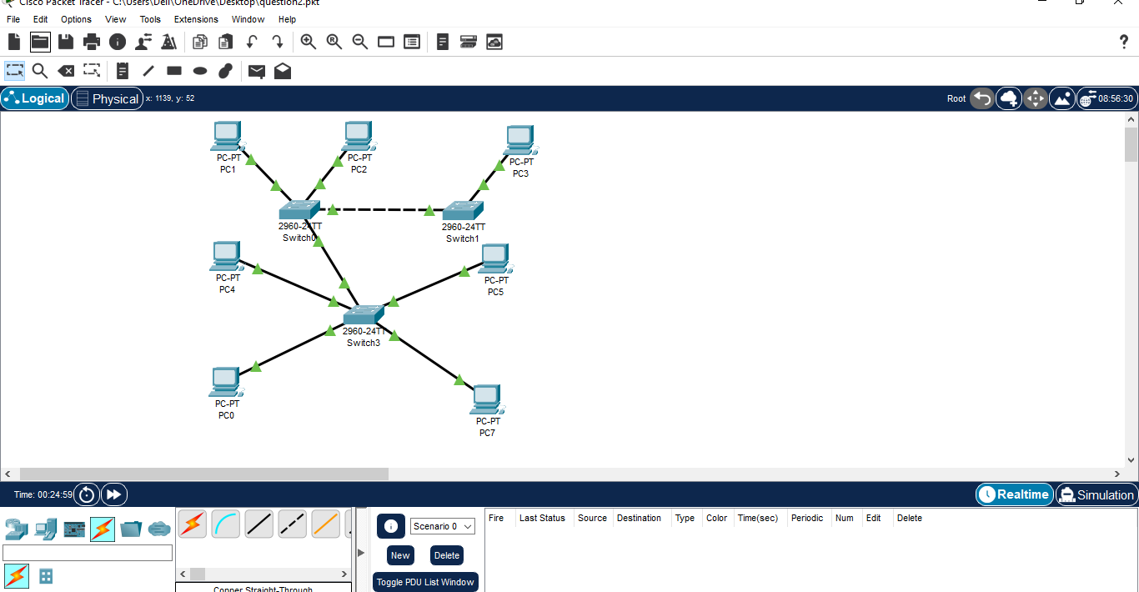

**2.Design the Bus topology with network id’s-192.168.0.2,192.168.0.3 and 192.168.0.4 ping it in command prompt. Also send the PDU in real time & simulation mode.**

Step-1-Make the Bus topology with the help of switches ,node(pc/computer) ,cable(copper straight through/copper cross-over).

Step-2-Configure the each node by given IP address.

Step-3-Check the connectivity through ping command.

Like-ping 192.168.0.2**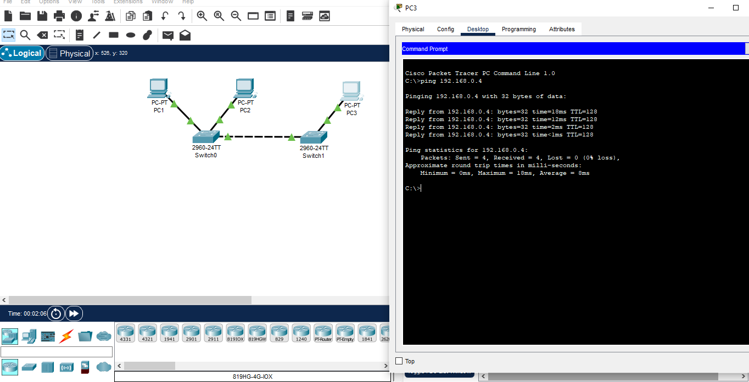3.Implement the Star topology Using hub.Configure it with 10.10.10.1 also check the connectivity using ping command.**

Step-1-Make the Star Topology with the help of Hub , node(Pc/Computers),Cable(Copper straight/Copper Cross-Over).

Step-2-Configure the node by given IP address.

Step-3-Check the connectivity through ping command.

